**Note**: The first clone and push attempt will each trigger a request for credentials. You should be able to use your Pavlovia account to sign in.

1. Download Atom at <https://atom.io/>
2. On Atom, go to Packages -> GitHub -> Toggle GitHub Tab
3. Click ‘Clone an existing GitHub repository’  
   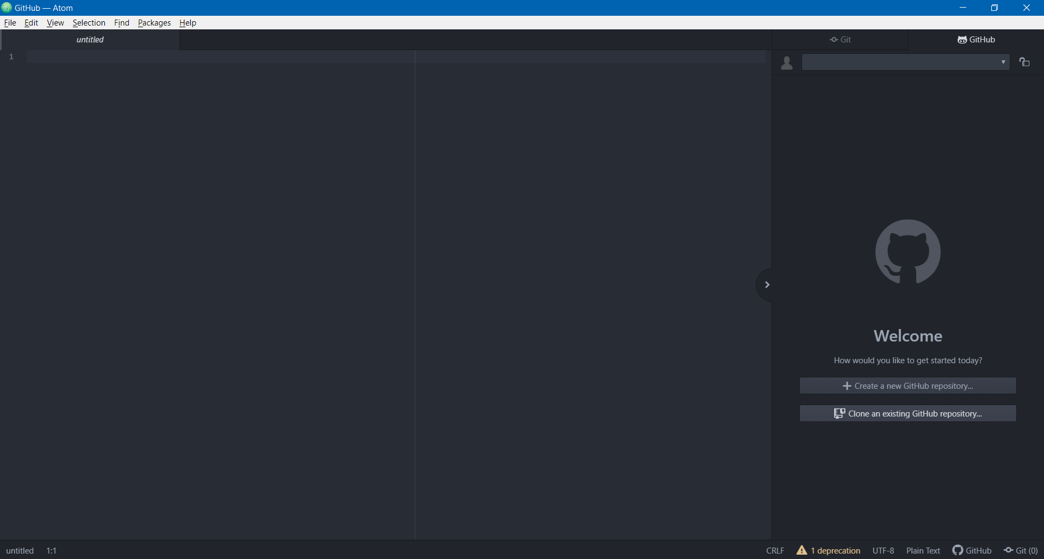
4. Enter the URL of your repository under “Clone from”. This is the URL of the home page of your repository, it should be in this format: http://gitlab.pavlovia.org/[your pavlovia username]/[your project’s name]  
     
   Enter your desired directory under “To directory”, as e.g. C:\Experiments\Project1
5. Now, you would see the folders and files on your Pavlovia GitLab here in Atom

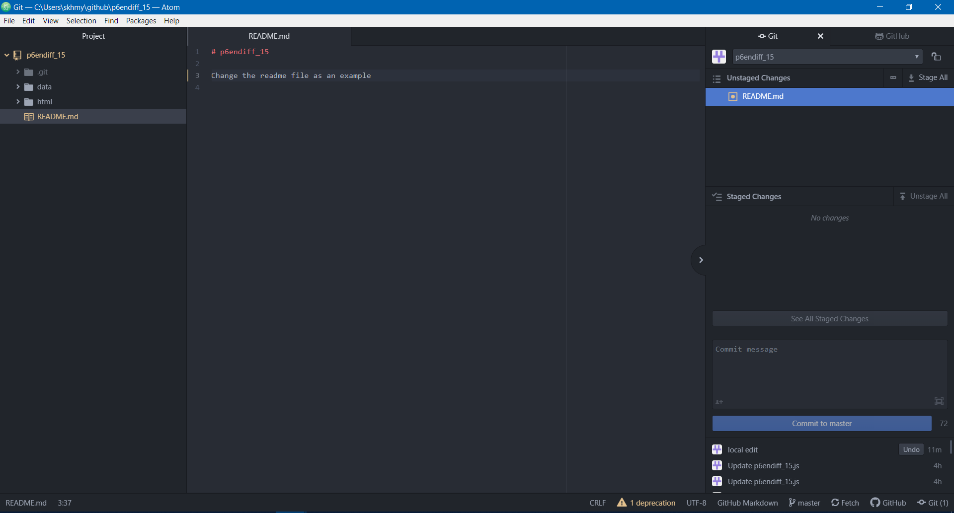

1. Make changes to the files as you wish. To push the changes to the repository (i.e. sync the changes to the repository), save the changes first. The saved changes would appear under ‘Unstaged Changes’ under the ‘Git’ tab (if your Git/GitHub tab disappeared, you can access it again through Packages -> GitHub)  
   
2. Double click on the changes to push them to ‘Staged Changes’, or click ‘Stage All’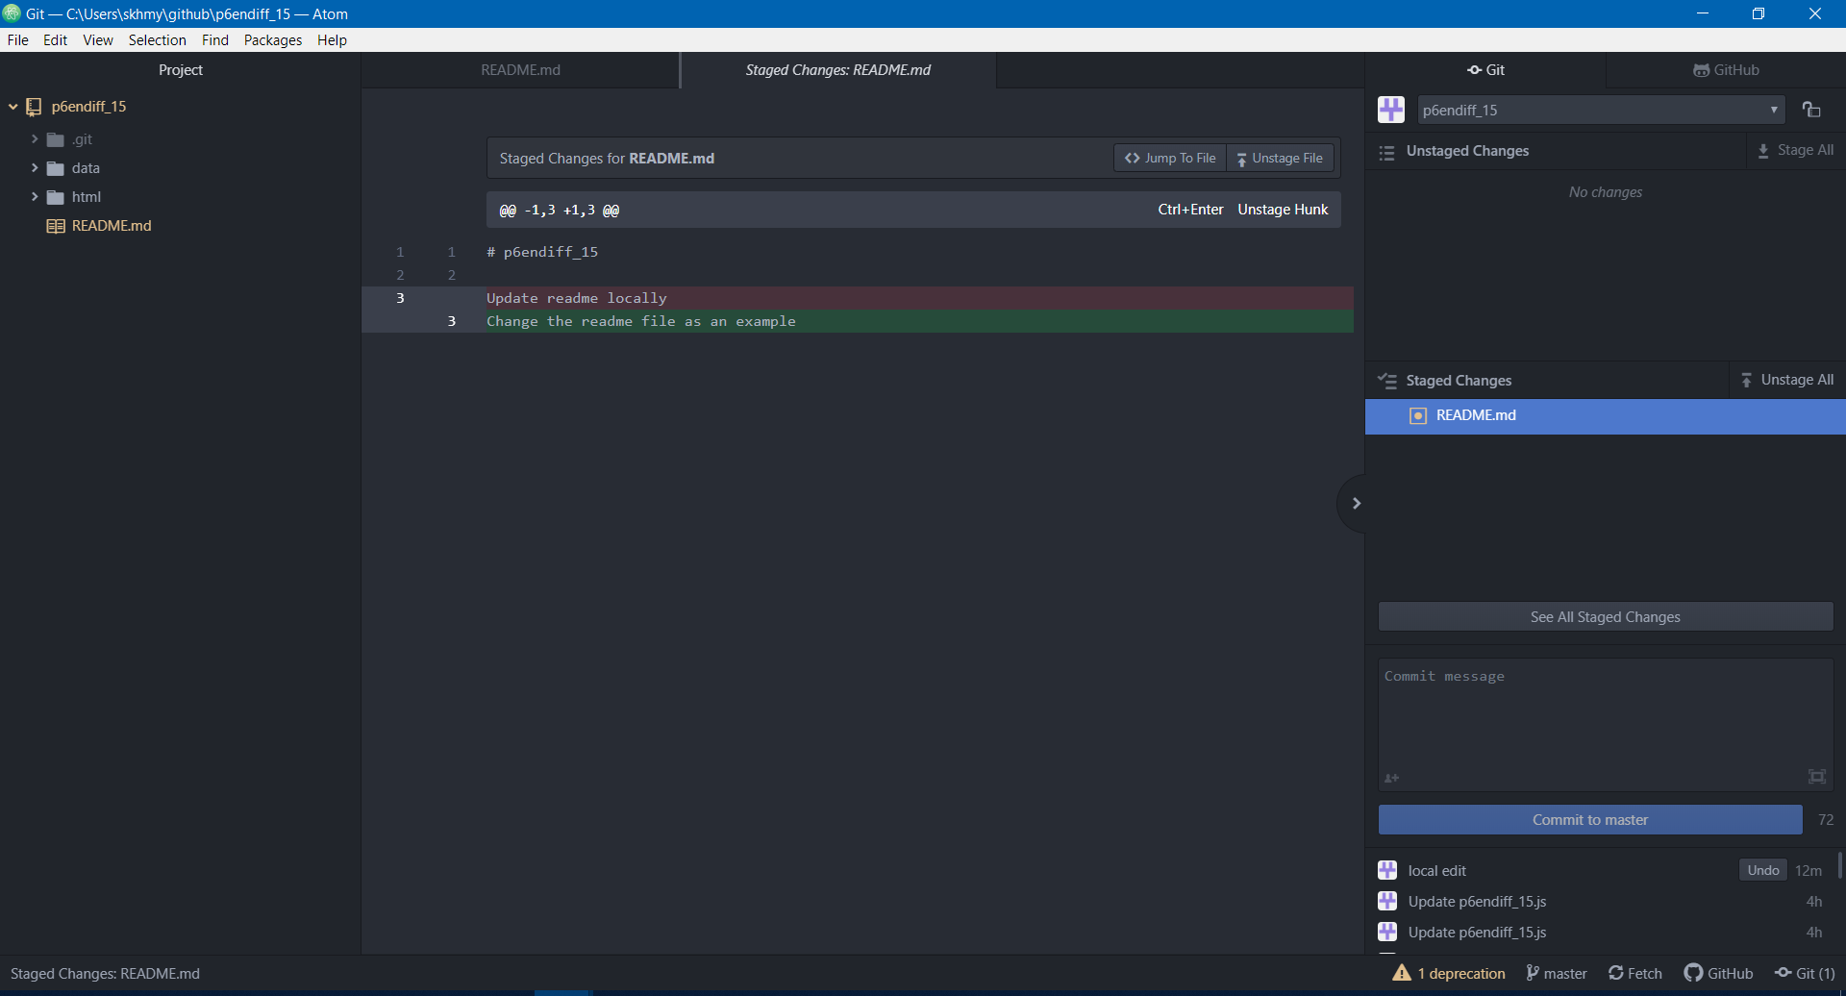
3. Enter a commit message to record what changes you made, then press ‘Commit to master’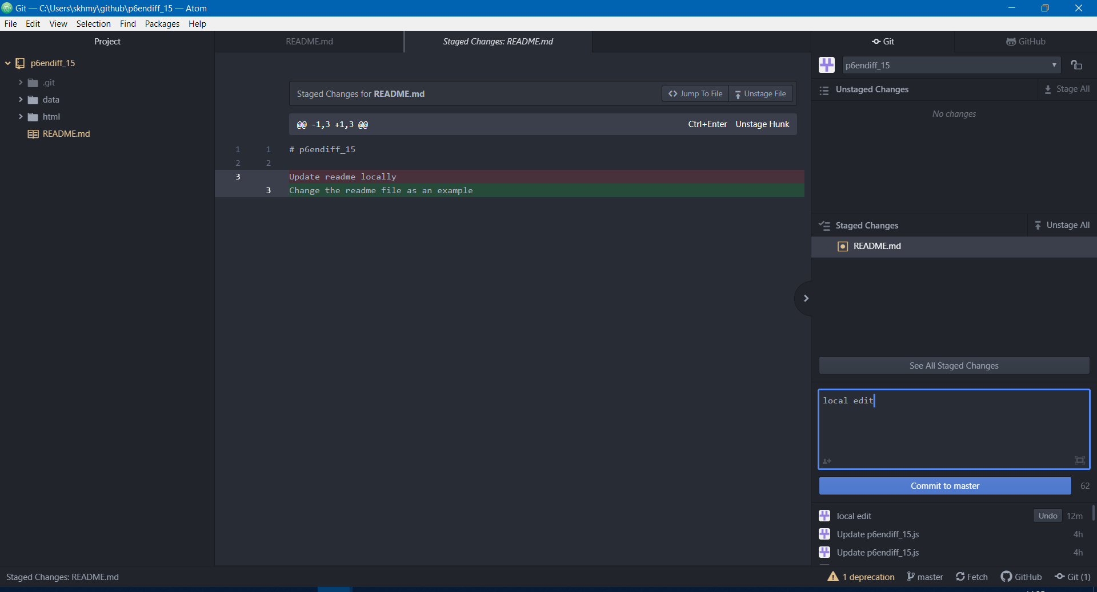
4. Click ‘Push’ to push to the repository online  
   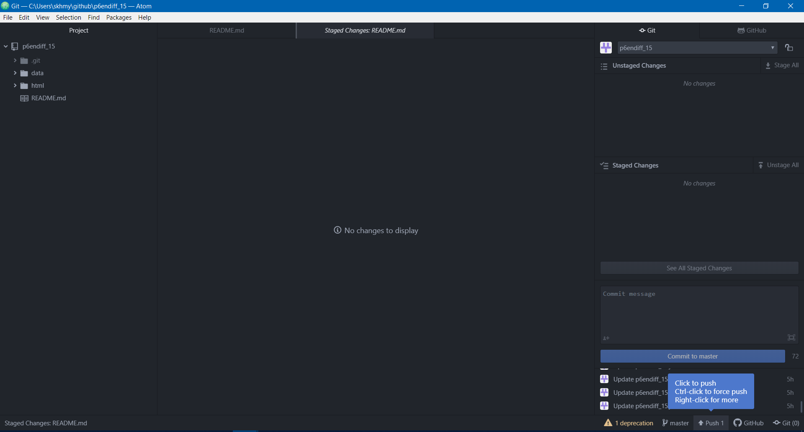
5. The changes you made on Atom should now be synced to your Pavlovia GitLab. You can then run the scripts through the ‘Pilot’ on the Pavlovia interface (or of course, with the experiment URL if the project is in RUNNING mode), or if you wish, run it locally on Atom (see 2. Run Locally)